

Analysis of Distribution Game with ERP Simulation

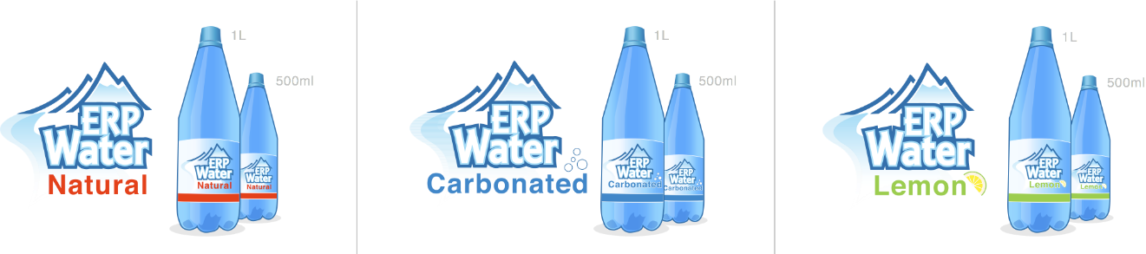

Team EE

CEO/ Marketing Manager: Erick Figueroa

Sales Manager: Francisco Ulloa

MM/ PO Manager: Karel Jie Tjoe Foek

# I. Initial Strategy………………………………………………………………………………… 3

a. Daily Inventory per Product ………………………………………………………………. 4

b. Daily Sales Quantity per Sales Area ……………………………………………………… 6

c. Daily Value Amount per Sales Area …………………………………………………….. 10

d. Daily Price Changes per Product per Plant …………………………………………........ 15

e. Daily Market Investment per Product by Sales Area ………………………………......... 17

II. Correlations …………………………………………………………………………………. 19

a. Inventory to Profits ……………………………………………………………………… 19

b. Price and Sales / Profits …………………………………………………………………. 25

III. Strategies by Plants ………………………………………………………………………… 31

IV. Conclusion …………………………………………………………………………………. 31

**I. Initial Strategy**

Our overall strategy was based on knowledge gained during the pilot run of the simulation. Based on the historical data developed during the pilot run, we were able to predict the rate at which certain products would sell and the associated price for these items. For example, we noted that we could impose a 30% to 40% markup on both versions of ClearPure water and they would sell fast enough to leave us without stock before day 10. However, in contrast the 500 mL Lemon Spritz would hardly sell at more than a 5% profit. We also decided to forego investing in marketing as the pilot run showed no substantial benefit.

During the first period, we attempted to find a price for each item which would allow for a consistent and even depletion of stock while still maintaining a 15% to 20% profit margin. This proved rather challenging as by day 5 ClearPure was sold out, yet we still had over 90% stock of the other products. On a positive note, due to our stock out of ClearPure our net profit increased to over €12,000. We slowly lowered the price on the Spritz and Lemon Spritz during the following days in an attempt to sell the remaining stock of these products. This reduction in price resulted in a much lower net profit for the rest of the quarter, with an ending net profit for the quarter of €18,602.

For the second period we modified our strategy slightly with respect to our sales of ClearPure. We noted during the previous quarter that all companies ran out of ClearPure within the first 10 days of the quarter. This stock out created a great demand in the market with no available supply to meet it. As a result, we decided to raise our prices for the ClearPure products early in the quarter in order to minimize their sales and thus retain our stock until later in the quarter. Due to this change in strategy we were able to sell the 1L ClearPure at up to a 108% markup and the 500 mL ClearPure at up to a 50% markup during the last 10 days of the quarter and make a substantial profit on these products.

By this point in the simulation we had maintained a decent lead and planned on capitalizing on our understanding of the market in order to dominate it. Rather than reorder the same 1000 units per product like in quarter 1 and quarter 2, we chose to modify our orders based on the market trends. We ordered only a 1000 or so units of the Spritz and Lemon Spritz, while quadrupling our order of ClearPure during the first day of quarter three. While we awaited our order to arrive, we priced our products based on the trends observed during quarters 1 and 2. Specifically, for our ClearPure products we lowered the profit margin of the 1L bottle down from 108% to 50% and the 500mL bottle down from 50% to 35%. As soon as our products arrived we had over €60,000 in sales in the first two days, which resulted in an increased net profit of €18,000 in just two days. During the rest of quarter 3 we attempted to float the price of all our products near the market average in an attempt to maintain a constant sales volume. As a result of this strategy we were able to dominate 40% of the market sales for the ClearPure products.

**a. Daily Inventory per Product**

Figure 1 - 1L Bottled Products



Figure 2 - 500mL Bottled Products



Figures 1 and 2 show the inventory of all 6 products over the 3 quarters. From these charts we can clearly see that the ClearPure products were in high demand. Due to high demand for ClearPure, team EE ordered a large amount of these for the third quarter knowing that we could make a large profit. In the other figures we can see that they only sold when ClearPure was out of stock.

**b. Daily Sales Quantity per Sales Area**

Figure 3 – Units Sold for Each Product by Sales Area (Team EE only)





Figure 3 shows the amount of units sold in each region for our team. As expected ClearPure in both packaging quantities sold the best. When we break it down by region, it is clear to see that most of our products sold best in the North. The only product that sold best in the West was 500mL Lemon Spritz.

Figure 4 - 1L ClearPure Team Sales Comparison



Figure 5 - 1L Lemon Spritz Team Sales Comparison



Figure 6 - 1L Spritz Team Sales Comparison



Figure 7 - 500mL ClearPure Team Sales Comparison



Figure 8 - 500mL Lemon Spritz Team Sales Comparison



Figure 9 - 500mL Spritz Team Sales Comparison



Figures 4-9 are a comparison between the winning team and team 2. The graphs show how many units each team sold in each region.

**c. Daily Value Amount per Sales Area**

Figure 10 – Value of Units Sold per Sales Area (Team EE only)





The graphs above depict the value of the amount of units sold by each region. This correlates directly with units sold.

Figure 11 – 1L ClearPure Team Value Comparison



Figure 12 – 1L Lemon Spritz Team Value Comparison



Figure 13 – 1L Spritz Team Value Comparison



Figure 14 – 500mL ClearPure Team Value Comparison



Figure 15 – 500mL Lemon Spritz Team Value Comparison



Figure 16 – 500mL Spritz Team Value Comparison



Figures 11-15 are a comparison of the value of units sold for the winning team and the team that came in second place. It is clear to see that the product that made the was most profitable was ClearPure in both configurations. Also, the North was the region were products sold the best followed by the South and then the West.

**Table 1:**



Table 1 is a summary of the figures presented previously. The table shows precisely where the most units were sold and the value associated with those units sold. The data below is for team EE. The boxed highlighted in blue are the ones that have the highest value for a product in a region. The orange highlighted box is for the most amount of units sold per product in a region.

The table show us that 1L ClearPure, 1L Lemon Spritz, 1L Spritz, 500mL ClearPure and 500mL Spritz sold best in the North.

500mL Lemon Spritz is the only product that sold best in the West.

**d. Daily Price Change per Product**

Figure 17 - 1L Bottled Products



Figure 18 - 500mL Bottled Products



From the graphs above we can conclude that the price changes reflect the demand of a product. As the demand of a product went up so did the price. The price for 1L ClearPure fluctuated the most. Most of the prices for each product were maintained at a reasonable profit margin.

**e. Daily Market Investment per Product Group**

Figure 19 - Daily Marketing Investment per Company

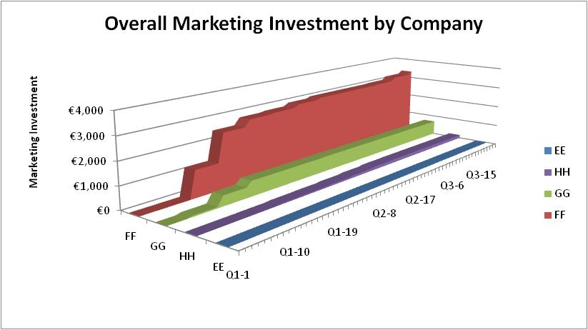

This graph shows our team’s decision of foregoing marketing expenses. Other teams invested up to €3,000 in marketing on a daily basis, but we were still able come on top from a net profit

Figure 20 - Daily Marketing Investment for 1L Water Bottles

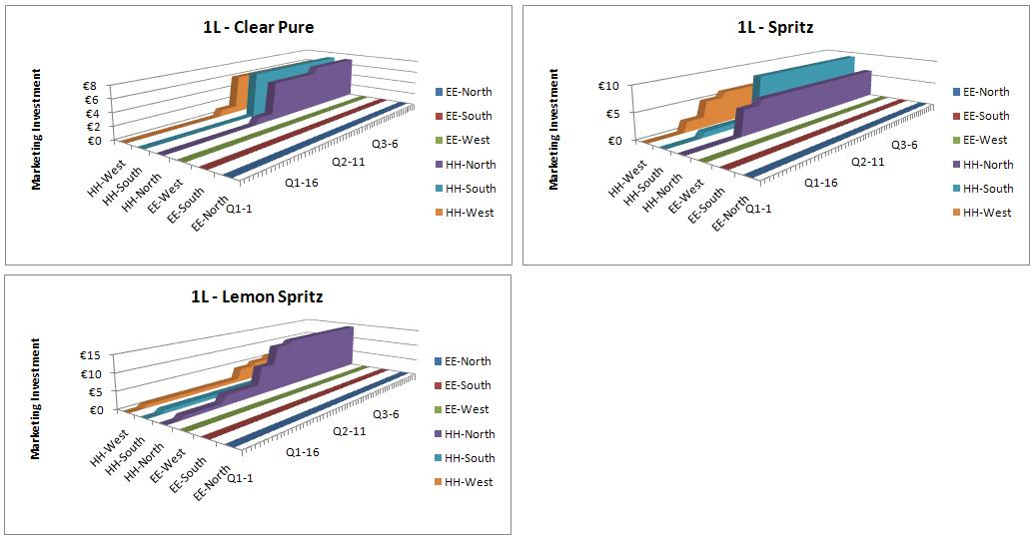

Figure 21 - Daily Marketing Investment for 500mL Water Bottles

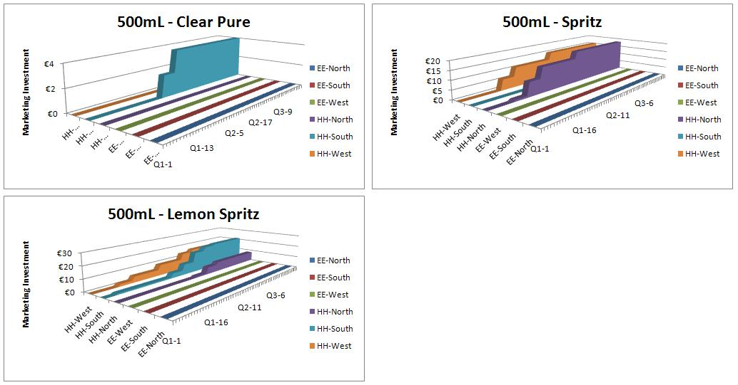

The second-placed team spent a minimal amount in marketing expenses as well

**II. Correlations**

**a. Inventory to Profits**

Figure 22 – 1L ClearPure Inventory vs. Profit Correlation Team Comparison

Figure 23 – 1L Lemon Spritz Inventory vs. Profit Correlation Team Comparison

Figure 24 – 1L Spritz Inventory vs. Profit Correlation Team Comparison

Figure 25 – 500 mL ClearPure Inventory vs. Profit Correlation Team Comparison

Figure 26 – 500 mL Lemon Spritz Inventory vs. Profit Correlation Team Comparison

Figure 27 – 500 mL Spritz Inventory vs. Profit Correlation Team Comparison

Figures 21 and 24 show a direct correlation between inventory level and profit for our team for the 1L and 500mL Clear Pure products compared to a negative correlation for team HH. Managing these products’ inventory levels allowed were key to achieving high profits

**b. Unit Price to Total Profit**

Figure 28 – 1L ClearPure Unit Price vs. Profit Correlation Team Comparison

Figure 29 – 1L Lemon Spritz Unit Price vs. Profit Correlation Team Comparison

Figure 30 – 1L Spritz Unit Price vs. Profit Correlation Team Comparison

Figure 31 – 500 mL ClearPure Unit Price vs. Profit Correlation Team Comparison

Figure 32 – 500 mL Lemon Spritz Unit Price vs. Profit Correlation Team Comparison

Figure 33 – 500 mL Spritz Unit Price vs. Profit Correlation Team Comparison

Figures 27 and 30 show a direct correlation product pricing and profit for our team for the 1L and 500mL Clear Pure products compared to a negative correlation for team HH. These two products were the highest contributors to the team’s net profit.

**III. Strategies by Plants**

Our closest competitor was plant HH and from our analysis it seems that they’re biggest weakness was controlling their inventory levels. They consistently ran out of stock before us, which allowed our plant to control the market and set higher prices.

This issue with inventory levels especially worked against them in quarter 3, where rather than forecasting an approximate demand based on previous experience and making one large order for their largest profit products, they made smaller batch orders. Normally, batch orders would not be a bad idea, however, they did not have sufficient inventory to allow for a trend to appear before they changed their prices to react to the market. Their pricing inconsistencies based on their fluctuating inventory levels, allowed our plant to flood the market with high inventory our best selling products at a healthy and consistent profit margin.

**IV. Conclusion**

Our plant was able to be successful and consistently lead the competition due to our careful monitoring and control of inventory levels. Based of inventory levels and their rate of use we priced our products with the intention of creating an even depletion. If a product sold too rapidly then we knew to raise the price and thus our profit margin for that product. If a product sold too slowly, we had to lower the price in order to maximize sales, or risk losing money due to unused inventory in stock.

Our plan to create maintain a consistent use of inventory levels in quarter 1 & 2 allowed for us to observe market trends that were of great use in quarter 3. Based off these observed trends, we maintained a relatively consistent stock of Spritz and Lemon Spritz from quarter 2 to quarter 3, but we substantially raised our stock of ClearPure to match the market demand we had observed. This plan proved quite fruitful as we dominated the market sales for ClearPure product in quarter 3 and were able to lead our closest competitor by over €25,000.

For the next game we plan to repeat our idea of controlling inventory levels and then pricing our products based on their inventory consumption. Hopefully, we will be able to duplicate our efforts from this game and continue to make the highest profit margin.